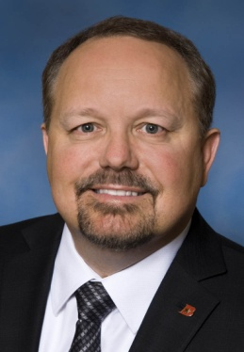

Michael W. (Mike) Rowland
Vice President
Market Manager--Military Liaison Officer
Broadway Bank
Fort Sam Houston, San Antonio, TX
(210)283-5390
mrowland@broadwaybank.com

Mike Rowland is the Fort Sam Houston Market Manager and Military Liaison Officer for Broadway Bank. He provides oversight for military banking matters within the Joint Base San Antonio (JBSA) region, including banking center locations on Fort Sam Houston, Randolph AFB, and Lackland AFB. His primary responsibility is serving as the liaison between Broadway Bank and all military units within JBSA. Mike also represents Broadway Bank in civic and community based organizations. Prior to joining Broadway Bank, Mike served in the United States Air Force for nearly 30 years, retiring in the rank of Chief Master Sergeant in December 2010. He was born and raised in Sterling Heights, MI and is married to the former Debi Lane, also from Sterling Heights, MI. They currently reside in Bulverde, TX.
Career Chronology
- July 2012-Present: Vice President, Military Market Manager and Liaison Officer, Broadway Bank
- November 2010-July 2012: Assistant VP, Military Business Development Officer, Broadway Bank
- July 1981-December 2010: United States Air Force, serving as Enlisted Flying Crew Chief, Enlisted Recruiter, Physician Recruiter, Recruiting Flight Chief, Recruiting Operations Chief, Recruiting Trainer, Recruiting Superintendent (4-state region), HQ Recruiting Service Marketing Superintendent, and Commandant of Air Force Recruiting School
Education and Training
- 2013: Masters of Business Administration, University of Phoenix
- 2001: Bachelor of Science, Business Administration (Cum Laude), Columbia Southern University
- 1987: Associate in Applied Science, Human Resources, Community College of the Air Force
- 2001: Certified Facilitator for Achieve Global “Professional Selling Skills” Core, Application, and Coaching fundamentals

Community and Civic Involvement
- 2014: Chairman, Celebrate America’s Military Committee, San Antonio Chamber of Commerce
- 2013: Chairman, Military Affairs Committee, San Antonio Chamber of Commerce
- 2012-2013: Member, Board of Directors, San Antonio Chamber of Commerce
- 2012: Chairman, Senior Enlisted Advisory Committee, San Antonio Chamber of Commerce
- 2011: Vice Chairman, Senior Enlisted Advisory Committee, San Antonio Chamber of Commerce
- 2011: Member of Celebrate America’s Military Committee, San Antonio Chamber of Commerce
- 2010-2015: Member, Board of Advisors, Association of U.S. Army
- 2010-2015: Member, Board of Advisors, U.S. Air Force Association

